**Results**

**Prediction of Cognitive Decline**

In the complete samples of CN, higher PET-BPAD significantly predicted CD in sample 1 (OR = 1.46, 95% CI [1.101, 2.106], p = .018), whereas a positive amyloid status significantly predicted CD (OR = 4.704, 95% CI [1.135, 23.604], p = .041) in sample 2. Classification of CD from only PET-BPAD yielded an AUC of 78% in sample 1. Here, 50% disease probability corresponded to a PET-BPAD of -0.1 years.

Results in the complete samples compared well to those found in the whole samples. PET- and MRI-BPAD were significantly associated with each other (r­sample1 = .390; psample1 < .0001; rsample2 = .385; psample2 < .0001). Again, MRI-BPAD (ORsample1 = 1.43, 95% CI [1.221, 1.709], p < .0001; ORsample2 = 1.36, 95% CI [1.169, 1.613], p< .001) and APOE-e4 carriership (ORsample1 = 4.088, 95% CI [1.804, 1.9.580], p < .001; ORsample2 = 5.276, 95% CI [2.435, 11.989], p< .0001) were highly significant predictors of CD. PET-BPAD, in this reduced sample, was not predictive of CD, while a positive amyloid status predicted CD in sample 1 (OR=3.22, 05% CI [1.15, 9.76], p < 0.05). Classification of CD from only the significant predictors yielded an AUC of 82% in both samples. 50% probability of CD corresponded to approximately 2.1 and 2.5 years in samples 1 and 2, respectively.

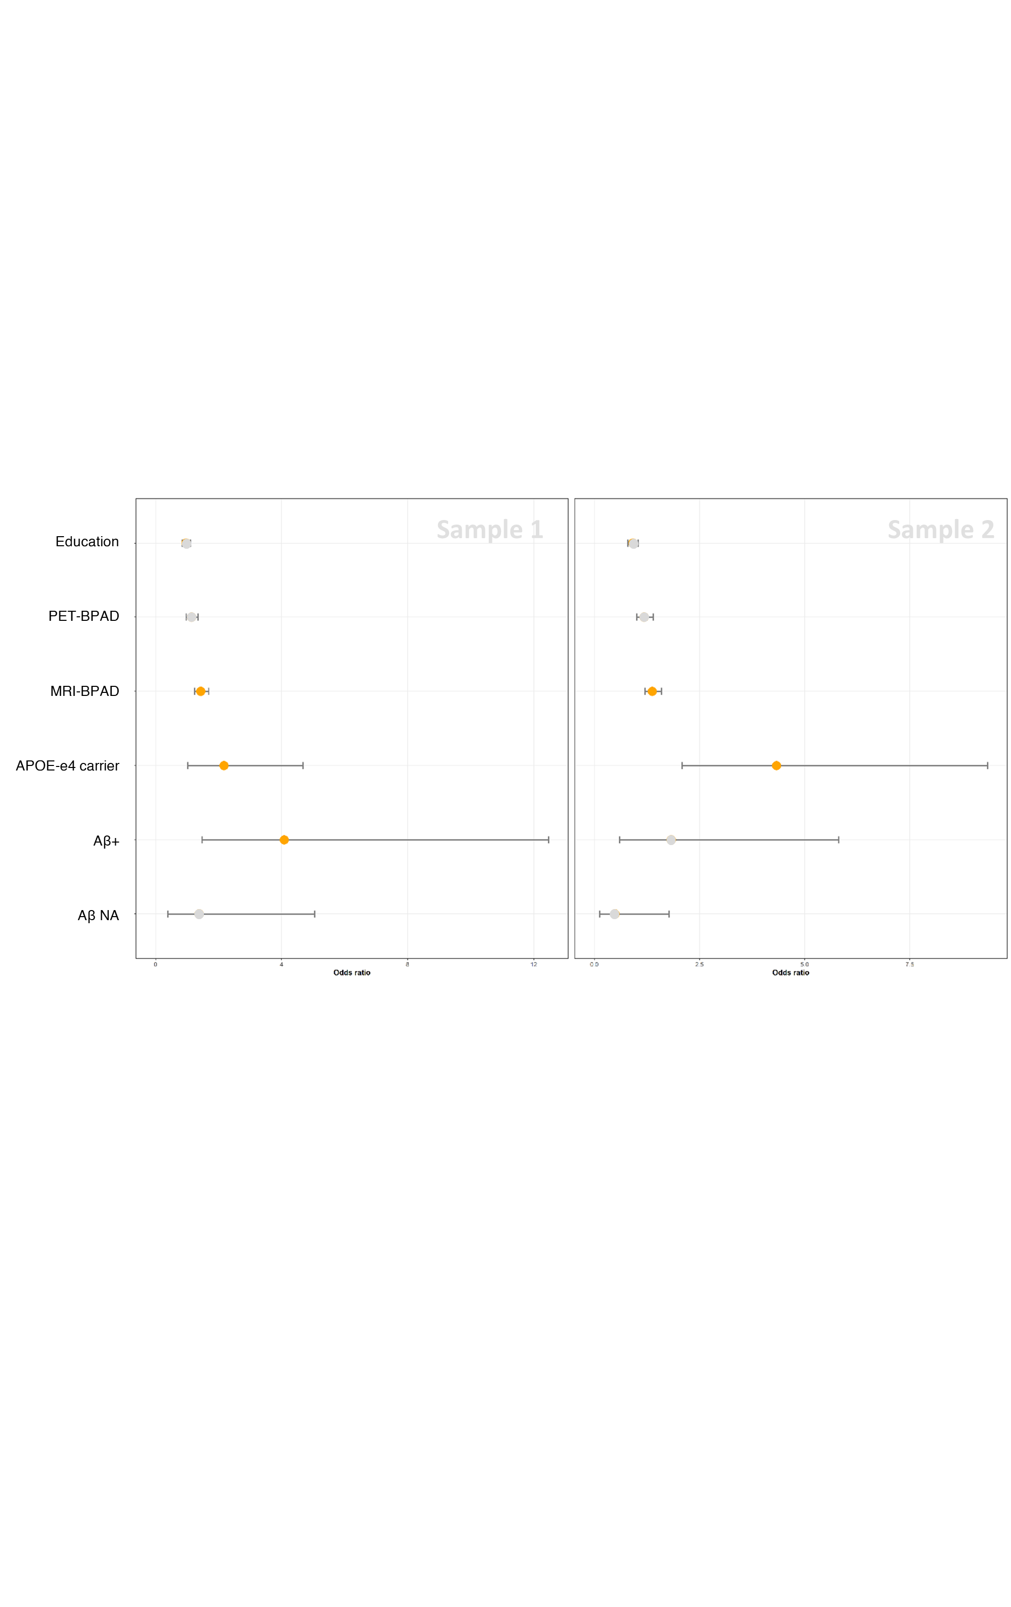

**Fig. S1. Odds ratios of whole sample classification of CD in MCI in sample 1 and 2.** Only predictors marked in orange were significant.

|  |  |  |
| --- | --- | --- |
| Table S1 Estimates (p-values) of logistic regression for prediction of cognitive decline in MCI whole samples as predicted from models 2 - 5. | | |
| Model 2 | | |
|  | Sample 1  (n = 200) | Sample 2  (n = 200) |
| PET-BPAD [Years] | .104 (.215) | .149 (.074) |
| MRI-BPAD [Years] | .413 (<.0001) | .354 (<.0001) |
| Aβ+ | 1.358 (.011) | .627 (.272) |
| APOE-ε4+ | .774 (.045) | 1.440 (<.001) |
| Education [Years] | -.027 (.691) | -.085 (.222) |
| Model 3 | | |
| PET-BPAD [Years] | .026 (.678) | .022 (.647) |
| MRI-BPAD [Years] | .420 (<.0001) | .316 (<.0001) |
| Aβ+ | 1.409 (.009) | .749 (.188) |
| APOE-ε4+ | .839 (.033) | 1.316 (<.001) |
| Education [Years] | -.032 (.646) | -.089 (.192) |
| Model 4 | | |
| PET-BPAD [Years] | -.010 (.875) | -.000 (.995) |
| MRI-BPAD [Years] | .445 (<.0001) | .359 (<.0001) |
| Aβ+ | 1.345 (.012) | .673 (.233) |
| APOE-ε4+ | .830 (.032) | 1.321 (<.001) |
| Education [Years] | -.046 (.504) | -.091 (.180) |
| Model 5 | | |
| PET-BPAD [Years] | .102 (.241) | .127 (.151) |
| MRI-BPAD [Years] | .371 (<.0001) | .314 (<.0001) |
| Aβ+ | 1.449 (.007) | .654 (.252) |
| APOE-ε4+ | .739 (.053) | 1.400 (<.001) |
| Education [Years] | -.026 (.700) | -.080 (.248) |
| Notes. Sample 1 and 2 were created with the same indices in all models. FDG-PET predicted brain age in models 3 and 4 used non-linear kernels, thus yielding deviating results to models 1, 2 and 5. | | |

|  |  |  |
| --- | --- | --- |
| Table S2. Estimates (p-values) of logistic regression for prediction of cognitive decline without PET-BPAD in whole samples. | | |
|  | MCI | |
|  | Sample 1  (n = 200) | Sample 2  (n = 200) |
| MRI-BPAD [Years] | .401 (<.0001) | .353 (<.0001) |
| Aβ+ | 1.361 (.01) | .583 (.31) |
| APOE-ε4+ | .835 (.03) | 1.41 (<.001) |
| Education [Years] | -.035 (.60) | -.09 (.18) |

|  |  |  |
| --- | --- | --- |
| Table S3. Estimates (p-values) of logistic regression for prediction of cognitive decline without MRI-BPAD in whole samples. | | |
|  | MCI | |
|  | Sample 1  (n = 200) | Sample 2  (n = 200) |
| PET-BPAD [Years] | .270 (<.001) | .274 (<.001) |
| Aβ+ | 1.744 (<.001) | 1.009 (.05) |
| APOE-ε4+ | .715 (.04) | 1.136 (<.01) |
| Education [Years] | -.02 (.75) | -.02 (.74) |

**Methods**

Bias-correction procedure without CA proposed by Cole et al. 31, which Beheshti et al. compared their proposed algorithm to. In this method, a linear regression model is fit on BPA versus CA. Without CA, bias-free brain age is then calculated as:

$${Predicted age}_{corrected without CA}=\frac{{Predicted age}_{uncorrected}-β}{α}$$

ADD TABLE FOR BIAS CORRECTION; ADD GRAPHIC OF BIAS CORRECTION; ADD